**Large Language Model Operating System**

1. **ABSTRACT**

This report explores the concept of a Large Language Model Operating System (LLM OS), an advanced AI-driven interface that transforms human-computer interaction by leveraging the capabilities of large language models (LLMs). LLM OS aims to navigate and operate computers through natural language, eliminating the need for traditional applications and app stores. The evolution from command-line interfaces to GUIs, and now to LLMs, highlights a shift towards more intuitive and adaptive user experiences.

**2.INTRODUCTION**

Large Language Model Operating Systems (LLM OS) represent a groundbreaking leap in human-computer interaction. By utilizing advanced AI, these systems enable natural, conversational interfaces that surpass traditional graphical user interfaces (GUIs). LLM OS aims to simplify and enhance user experience, making traditional apps and interfaces obsolete. This report explores the concept, features, and transformative potential of LLM OS, highlighting its ability to adapt to user needs and revolutionize personal computing and various industries.

**3.OBJECTIVE:**

To explore the concept, features, and transformative potential of Large Language Model Operating Systems (LLM OS).

**4.METHODOLOGY**

1.Define Objectives: Clearly outline the goals and objectives of the LLM OS. Determine the specific tasks and functions it should perform to meet user needs effectively.

2.Gather Requirements: Identify the requirements for the LLM OS, including the tools, assistants, and knowledge base needed to support its functionality.

3.Set Up Environment: Configure the development environment by installing necessary libraries and dependencies. Set up logging to facilitate debugging and monitoring.

4.Design Core Components: Define the core components of the LLM OS, including tools for various tasks and assistants for specific roles or domains.

5.Develop LLM OS Setup Function: Create a setup function responsible for initializing the LLM OS instance. This function should instantiate tools, assistants, and configure the knowledge base.

6.Implement Tools and Assistants: Develop the functionality of tools and assistants based on predefined roles and tasks. Ensure each assistant has access to relevant tools and instructions.

7.Integrate Knowledge Base: Populate the knowledge base with relevant documents, data, or information sources. Implement mechanisms for searching and retrieving knowledge.

8.Test and Debug: Conduct thorough testing of the LLM OS to identify and resolve any issues or errors. Test its functionality across different scenarios and user inputs.

9.Refine and Optimize: Continuously refine and optimize the LLM OS based on user feedback and performance evaluations. Enhance its capabilities and efficiency over time.

10.Deploy and Maintain: Deploy the LLM OS for user access, ensuring scalability, reliability, and security. Regularly maintain and update the system to address evolving needs and challenges.

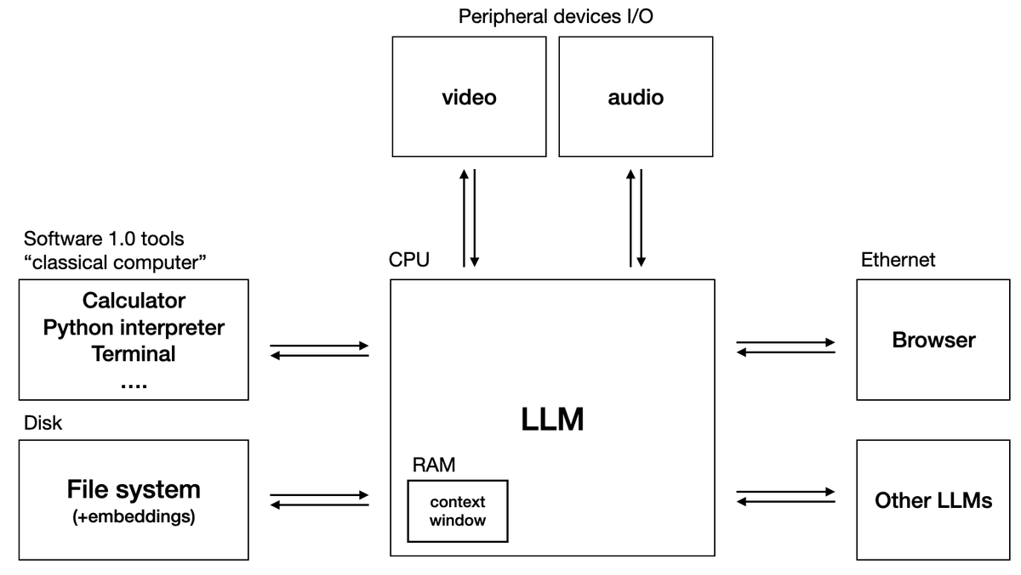

**5.SIGNIFICANCE**

The LLM OS revolutionizes user assistance by integrating advanced AI models, diverse tools, and specialized assistants into a unified platform. It streamlines tasks, enhances productivity, and provides tailored support across various domains, marking a significant leap forward in AI-driven user interaction and problem-solving.

**7.TECHNOLOGIES USED**

Python, OpenAI GPT, PostgreSQL, NLP Libraries (phi, nltk), Document Readers , Web Scraping, Asyncio, Logging, Toolkit Modules , Vector Databases , External APIs (e.g., DuckDuckGo, YFinance)

**8.References**

1. <https://mer.vin/2024/05/phidata-llm-os/>
2. <https://github.com/phidatahq/phidata/tree/main/cookbook/llm_os>
3. <https://medium.com/@protegeigdtuw/part-1-introduction-to-llm-os-1cfec39689f7>
4. <https://www.youtube.com/watch?v=YMZm7LdGQp8>